SOFTWARE REQUIREMENTS SPECIFICATION
PhishGuard
Intelligent Phishing Website Detection using Machine Learning,
Explainable AI (SHAP), and FastAPI
Submitted to | Smita Dixit Kansal  Assistant Professor  Department of Information Technology
Submitted by | Yash Gangal  Student
Institution | Institute of Technology and Science, Mohan Nagar, Ghaziabad
Document | Version 1.0 | 19 August 2026

Document purpose: Defines the requirements, operating scenarios, interfaces, data contracts, quality targets, and acceptance criteria for the PhishGuard mini-project.

Contents
This contents list follows the section structure of the retained SRS template. Detailed page numbering is intentionally left to Word's field update when the document is opened.
1. Purpose
2. Scope
3. Intended Audiences
4. Definitions and Abbreviations
5. References
6. Assumptions and Dependencies
7. Problem Statement
8. Overall Description
9. Use Cases
10. Functional Requirements
11. Data Requirements
12. Non-Functional Requirements
13. Activity Diagram
14. Flow Chart
15. Acceptance Criteria
16. Risks, Constraints, and Future Work
Appendix A - API Summary
Appendix B - Feature Dictionary

1. Purpose
This Software Requirements Specification (SRS) defines the functional, non-functional, data, interface, and operational requirements for PhishGuard. PhishGuard is a web-based phishing website detection system that accepts an absolute URL, extracts URL and optional webpage signals, produces an explainable machine-learning assessment, and stores an auditable scan record.
The document is intended for the supervisor, student developer, testers, reviewers, and future maintainers. It establishes the baseline for implementation, testing, demonstration, and academic evaluation.

2. Scope

2.1 In scope
• Validate and submit absolute HTTP(S) URLs through the user interface and FastAPI API.
• Extract 15 URL-structure features and 7 optional HTML/DOM features.
• Perform bounded best-effort webpage retrieval with URL-only degradation when retrieval fails.
• Run the active trained model or the configured deterministic heuristic fallback.
• Return phishing/legitimate verdict, confidence, 0-100 risk score, risk tier, and top contributing signals.
• Persist scan history and active-model metadata in SQLite.
• Support history review, filtering, pagination, deletion, analytics, model information, API documentation, and printable reports through the planned frontend.

2.2 Out of scope
• Blocking or quarantining webpages directly in a browser, proxy, or network gateway.
• Guaranteed detection of every zero-day or previously unseen phishing campaign.
• Paid reputation, blacklist, or third-party threat-intelligence API integration.
• Authentication, role-based access control, and multi-tenant isolation in the mini-project version.
• Automatic takedown, remediation, or notification of website owners.

3. Intended Audiences
Audience | Use of this document
Supervisor / reviewer | Evaluate completeness, feasibility, traceability, and academic project alignment.
Student developer | Use as the implementation and integration baseline.
Backend / frontend developers | Implement API contracts, UI behavior, service boundaries, and data handling.
Testers | Derive unit, integration, negative-path, performance, and acceptance tests.
Future maintainers | Understand assumptions, risks, model behavior, and deferred work.

4. Definitions and Abbreviations
Term | Definition
SRS | Software Requirements Specification.
URL | Uniform Resource Locator submitted for analysis.
HTML / DOM | Webpage markup and its parsed Document Object Model.
SHAP | SHapley Additive exPlanations; a method used to rank feature contributions.
XAI | Explainable Artificial Intelligence.
ML | Machine Learning.
Risk score | Integer from 0 to 100 derived from phishing probability.
URL-only analysis | Analysis using the 15 URL features when HTML retrieval is unavailable.
Fallback model | Deterministic heuristic classifier used when a trained artifact is unavailable and fallback is enabled.

5. References
- Retained SRS template: docs/SRSTemplate_v1.0.docx.
- PhishGuard project overview and architecture guide: OVERVIEW.md.
- System architecture: files/01_system_architecture.md.
- Database schema: files/02_database_schema.md.
- API contract: files/03_api_contract.md.
- Feature engineering specification: files/04_feature_engineering_spec.md.
- Model comparison report: phishing_detector/backend/ml/comparison_report.json.
- Backend implementation and tests: phishing_detector/backend/app and phishing_detector/backend/tests.

6. Assumptions and Dependencies
Category | Assumption / dependency
Runtime | Python 3.11 is the supported backend runtime for the pinned scientific-ML dependencies.
Frontend | The planned frontend uses React 18, Vite, Tailwind CSS, Chart.js, and Lucide icons.
Backend | FastAPI, Uvicorn, Pydantic, SQLAlchemy, Requests, BeautifulSoup4, tldextract, scikit-learn, NumPy, and SHAP are available as configured.
Model artifact | The trained artifact is optional for demonstration because the configured heuristic fallback can serve offline scans.
Network | HTML enrichment depends on outbound access to the target URL and can fail or time out.
Persistence | SQLite is appropriate for mini-project scale; production-scale concurrency may require a server database.
Security | Fetching arbitrary URLs is treated as a security-sensitive operation and requires production SSRF controls beyond this baseline.

7. Problem Statement
Phishing websites imitate trusted services to collect credentials, payment information, or other sensitive data. Static blacklists can lag behind short-lived or newly generated domains. Paid reputation services can reduce implementation effort, but they introduce cost, network dependence, rate limits, and limited transparency into why a URL was flagged.
PhishGuard addresses this gap with a self-contained, explainable workflow that evaluates URL structure and optional webpage characteristics, returns a phishing or legitimate assessment, shows risk and evidence, and stores an auditable scan record. The workflow remains useful when the target site is offline, blocked, or too slow to fetch.
Project goal: Provide a fast, explainable, and auditable phishing-risk assessment without requiring paid threat-intelligence APIs.

7.1 Objectives
• Return a typed prediction through POST /predict after validating the submitted URL.
• Use a 22-feature hybrid vector: 15 always-available URL signals and 7 optional HTML signals.
• Use the benchmark-selected Random Forest model when its artifact is available, with a clearly identified heuristic fallback for offline demonstration.
• Provide confidence, a risk score from 0 to 100, low/medium/high risk tiers, and human-readable evidence.
• Persist the complete scan result with model version and UTC timestamp.
• Support analyst review through history, analytics, model metadata, and printable reports.

7.2 Scenario Document
Primary operating scenario - a user submits a URL for analysis:
- The user opens the Overview or Scan URL workspace and enters an absolute HTTP(S) URL.
- The frontend performs basic format validation and shows an inline error if the value is missing or malformed.
- The frontend sends the URL to POST /predict. FastAPI validates the request using the typed schema.
- The scraper makes a bounded best-effort request to the target page and counts redirects if the page responds.
- The feature service extracts 15 URL features and, when HTML is available, 7 HTML/DOM features. Otherwise it marks html_features_available=false and uses safe defaults for the HTML features.
- The model service loads the active model or permitted fallback, calculates phishing probability, prediction, confidence, risk score, and risk tier.
- The explainability service ranks the top five contributing signals using SHAP when supported or the deterministic fallback explanation otherwise.
- The database persists the complete result and model version in SQLite.
- The frontend displays verdict, confidence, risk, evidence, the full feature matrix, and an optional degradation note.
- The user can open the report, review the record later in history, or inspect aggregate analytics.

7.3 Exception Scenarios
Condition | Expected behavior
Malformed URL | Return HTTP 422 with a human-readable validation detail; do not create a history row.
Target timeout, DNS, TLS, or HTTP failure | Complete URL-only analysis, set html_features_available=false, and show the degradation note.
Model artifact missing | Use the fallback when enabled and identify it in model metadata; otherwise return HTTP 503.
Unexpected extraction or persistence failure | Rollback the transaction, log the failure, and return HTTP 500 with a generic detail.
Unknown history id | Return HTTP 404 and leave existing records unchanged.
Concurrent scans | Create independent records without partial or cross-linked results.

8. Overall Description

8.1 Product Perspective
PhishGuard is organized as a presentation layer, FastAPI API layer, feature services, ML/XAI services, and SQLite persistence. The planned React frontend communicates with the backend through JSON REST endpoints. The target website is an untrusted external input source used only for bounded enrichment.
Layer | Responsibility | Representative technology
Presentation | URL input, verdicts, history, analytics, model/API information, and report view. | React 18, Vite, Tailwind CSS, Chart.js
API | Typed request/response contract, routing, validation, CORS, health, and orchestration. | FastAPI, Pydantic, Uvicorn
Feature services | URL parsing, HTML retrieval, DOM parsing, and 22-feature aggregation. | urllib, tldextract, Requests, BeautifulSoup4
ML / XAI | Model loading, probability inference, risk mapping, and top-five explanation. | scikit-learn, Random Forest, SHAP, NumPy
Persistence | Scan history and active-model metadata. | SQLite, SQLAlchemy, JSON

8.2 Product Functions
• Quick scan from the overview and dedicated Scan URL workspace.
• Verdict display with confidence, risk score, risk tier, and top contributing signals.
• Full 22-feature matrix with HTML availability indicator.
• History search, filtering, pagination, detail view, deletion, and CSV export behavior.
• Analytics cards and model comparison visualization.
• Active model metadata, endpoint documentation, health status, and Swagger UI access.
• Print/PDF-ready detailed scan report.

8.3 User Characteristics
The primary user is an analyst, student, reviewer, or developer who can enter a URL and interpret a basic risk verdict. The interface must not require knowledge of feature engineering or model internals to understand the primary outcome, while still exposing enough evidence for technical review.

8.4 Operating Environment
• Development API: http://localhost:8000.
• FastAPI interactive documentation: http://localhost:8000/docs.
• Frontend development server: http://localhost:5173.
• SQLite database retained on local disk.
• Modern desktop browser for the planned responsive React interface.

8.5 Constraints
• The model output is a risk assessment, not a guarantee or a replacement for analyst judgment.
• HTML features are unavailable for unreachable targets and must be disclosed to the user.
• SQLite is not intended for high-volume production concurrency.
• The mini-project baseline has no authentication or access-control boundary.
• External page fetching requires production controls against SSRF, excessive response sizes, and unsafe network access.

9. Use Cases

9.1 Use Case Diagram
The diagram identifies the analyst/user as the primary actor and the target website as an optional enrichment source.
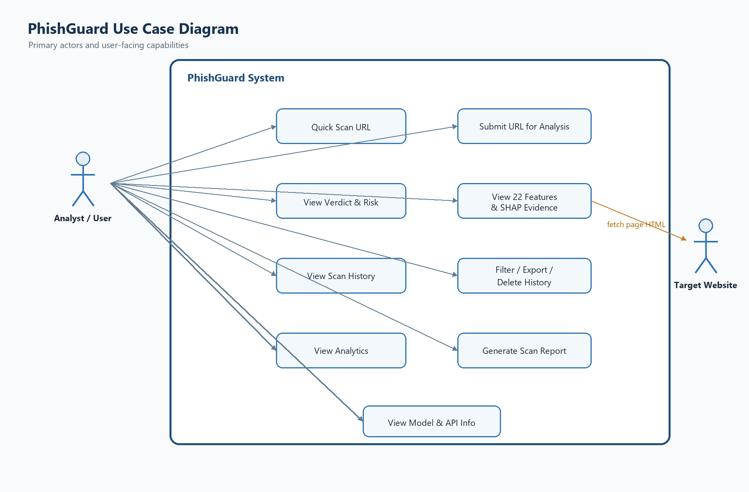
Figure 9-1. PhishGuard use case diagram.

9.2 Use Case Summary
ID / use case | Primary actor | Precondition | Success outcome
UC-01 Submit URL | Analyst / User | Scan page is available. | A valid URL is sent to POST /predict.
UC-02 Review verdict | Analyst / User | A scan response exists. | Prediction, confidence, risk, and evidence are visible.
UC-03 Review history | Analyst / User | Database is reachable. | Paginated records are displayed and can be filtered.
UC-04 Manage history | Analyst / User | A history record is selected. | Record is viewed, exported, or deleted after confirmation.
UC-05 Review analytics | Analyst / User | History/model data is available. | Aggregate scan and model metrics are visible.
UC-06 Generate report | Analyst / User | A detailed scan is selected. | A print/PDF-ready report is displayed.
UC-07 Enrich scan | Target Website | URL is syntactically valid. | HTML features and redirect count are added when reachable.

9.3 Primary Use Case Narrative - UC-01 Submit URL
Field | Description
Primary actor | Analyst / User
Trigger | User selects Scan after entering a URL.
Preconditions | Frontend and API are available; the URL field is visible.
Main flow | Validate input, call POST /predict, fetch page if enabled, extract features, infer, explain, persist, and render the result.
Alternate flow | If the target cannot be fetched, continue with URL-only features and disclose the limitation.
Failure flow | Return 422 for invalid input, 503 for unavailable model without fallback, or 500 for an unexpected server failure.
Postcondition | A successful scan is stored and the user can review the verdict and evidence.

10. Functional Requirements

10.1 API Input and Validation
ID | Requirement | Priority | Verification
REQ-001 | The system shall expose GET /health and report service status, model readiness, and database connectivity. | Must | API test
REQ-002 | The system shall accept a JSON request containing one required url field. | Must | Schema test
REQ-003 | The system shall reject missing, malformed, or non-absolute URL values with HTTP 422. | Must | Negative API test
REQ-004 | The system shall normalize the submitted URL to a string and persist the hostname/domain in lowercase. | Must | Integration test
REQ-005 | The system shall return human-readable error details without exposing stack traces to the client. | Must | Error-path test

10.2 Feature Engineering and Inference
ID | Requirement | Priority | Verification
REQ-006 | The system shall attempt a bounded webpage fetch using a configurable timeout and a PhishGuard user agent. | Must | Integration test
REQ-007 | The system shall extract all 15 URL features for every syntactically valid URL without requiring a network call. | Must | Unit test
REQ-008 | The system shall extract seven HTML/DOM features when page HTML is available and set html_features_available=true. | Must | Unit/integration test
REQ-009 | When the target page cannot be fetched, the system shall use safe defaults for the seven HTML features, set html_features_available=false, and continue URL-only prediction. | Must | Failure-path test
REQ-010 | The system shall load the active trained model when available or use the configured deterministic fallback when permitted. | Must | Configuration test
REQ-011 | The system shall classify each scan as exactly phishing or legitimate based on the active model probability threshold. | Must | Unit/API test
REQ-012 | The system shall return confidence as a decimal in the range 0.0 to 1.0 for the selected prediction. | Must | Schema test
REQ-013 | The system shall calculate an integer risk score from 0 to 100 using the phishing probability. | Must | Unit test
REQ-014 | The system shall map risk scores 0-33 to low, 34-66 to medium, and 67-100 to high. | Must | Boundary test
REQ-015 | The system shall return the five largest absolute feature contributions using SHAP where supported and a deterministic fallback explanation otherwise. | Must | Unit/API test

10.3 Persistence and History
ID | Requirement | Priority | Verification
REQ-016 | The system shall persist scan id, URL, domain, prediction, confidence, risk score, risk level, features JSON, top-features JSON, model version, and UTC timestamp. | Must | Database inspection
REQ-017 | The system shall create or reuse metadata for the model version used by a scan, including metrics when available. | Must | Database inspection
REQ-018 | The system shall return paginated history records in reverse chronological order. | Must | API test
REQ-019 | The history endpoint shall support optional filtering for phishing or legitimate records. | Must | API test
REQ-020 | The system shall delete an existing history record only when its identifier exists and shall return HTTP 404 for an unknown identifier. | Must | API test
REQ-021 | The frontend shall provide a confirmation step before deleting a history record. | Should | UI demonstration

10.4 Frontend, Analytics, and Reporting
ID | Requirement | Priority | Verification
REQ-022 | The Overview page shall expose health, active-model information, a quick scan input, and the latest scan summary. | Should | UI demonstration
REQ-023 | The Scan URL workspace shall show validation, active-analysis state, verdict, confidence, risk score, risk level, and degradation status. | Must | UI demonstration
REQ-024 | The result view shall display the top five contributing signals with value, impact, direction, and plain-language meaning where available. | Must | UI demonstration
REQ-025 | The result view shall expose the full 22-feature matrix and indicate whether HTML enrichment was available. | Must | UI demonstration
REQ-026 | The History page shall provide search/filter controls, pagination, detail viewing, deletion, and CSV export behavior. | Should | UI demonstration
REQ-027 | The Analytics page shall display total scans, phishing count/percentage, average confidence, model accuracy, and comparison artifacts when available. | Should | UI demonstration
REQ-028 | The Model and API page shall display active-model metadata, endpoint descriptions, health status, and Swagger UI access. | Should | UI demonstration
REQ-029 | The report page shall present a print/PDF-ready audit view containing URL, verdict, risk, evidence, feature matrix, model signature, and timestamp. | Should | UI demonstration

10.5 Reliability and API Documentation
ID | Requirement | Priority | Verification
REQ-030 | The backend shall log bounded scrape failures with diagnostic context without returning sensitive internal exception details to the client. | Must | Log inspection
REQ-031 | The backend shall roll back the database transaction when prediction persistence fails. | Must | Failure-path test
REQ-032 | The API shall expose OpenAPI/Swagger documentation for supported endpoints. | Must | Endpoint inspection

11. Data Requirements

11.1 ScanHistory
Field | Type | Required | Description
id / scan_id | Integer | System | Auto-incrementing identifier for the scan.
url | VARCHAR(2048) | Yes | Validated URL submitted by the user.
domain | VARCHAR(255) | System | Lowercase hostname extracted from the URL.
prediction | VARCHAR(20) | System | phishing or legitimate.
confidence | FLOAT | System | Confidence for the selected prediction, 0.0-1.0.
risk_score | INTEGER | System | Phishing probability mapped to 0-100.
risk_level | VARCHAR(10) | System | low, medium, or high.
features_json | TEXT | System | 22 named features plus html_features_available.
top_features_json | TEXT | System | Top five contributing signals and directions.
model_version | VARCHAR(50) | System | Model artifact or fallback version used for the scan.
scanned_at | DATETIME | System | UTC timestamp for the completed scan.

11.2 ModelMetadata
Field group | Description
Identity | id, model_name, algorithm, version, and is_active.
Evaluation | accuracy, precision, recall, f1_score, and roc_auc when a benchmark report is available.
Training context | dataset_size, trained_at, file_path, and optional notes.

11.3 Data Integrity Rules
• Prediction values are restricted to phishing or legitimate.
• Risk score is an integer between 0 and 100, and risk level follows the documented boundaries.
• Each successful scan references the model version that generated the result.
• History is ordered by scanned_at descending for the default API response.
• Features and top-feature explanations are stored as JSON so the complete evidence can be reconstructed for a report.

12. Non-Functional Requirements
ID | Category | Requirement | Verification
REQ-033 | Performance | For URL-only analysis under normal local conditions, the API should return a prediction within 500 ms after request validation, excluding external page-fetch time. | Performance test
REQ-034 | Reliability | The webpage fetch shall use a bounded timeout and shall not prevent a response when the target is offline or unreachable. | Failure-path test
REQ-035 | Compatibility | The system shall use strict typed request/response schemas and shall not silently accept malformed URL input. | Contract test
REQ-036 | Architecture | The baseline workflow shall avoid paid third-party threat-intelligence APIs. | Architecture inspection
REQ-037 | Usability | The frontend shall present risk, confidence, evidence, and HTML availability with clear visual distinction and readable labels. | UI inspection
REQ-038 | Maintainability | Routing, feature extraction, scraping, inference, explainability, persistence, and schemas shall remain separable modules. | Code review
REQ-039 | Durability | Scan history shall persist across backend restarts when the SQLite database is retained. | Restart test
REQ-040 | Testability | The application shall be testable with feature unit tests and API tests for health, prediction, history, validation, and deletion. | Test run
REQ-041 | Transparency | The system shall disclose whether the result used full HTML enrichment or URL-only fallback. | UI/API inspection
REQ-042 | Security | Production deployments shall apply SSRF protections, response-size limits, outbound network restrictions, and safe logging around target-page fetches. | Security review

13. Activity Diagram
The activity flow below describes the request lifecycle from URL entry through validation, optional enrichment, feature extraction, inference, explanation, persistence, and UI rendering.
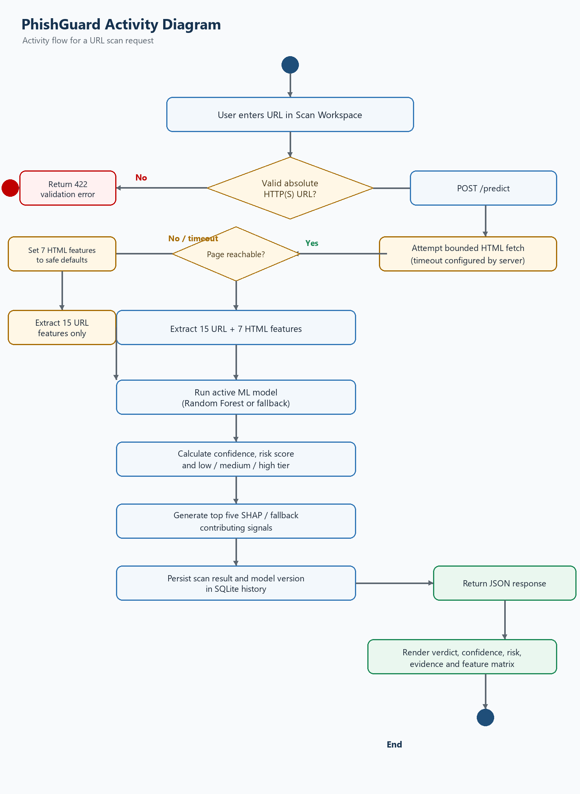
Figure 13-1. PhishGuard activity diagram for a URL scan request.

14. Flow Chart
The flow chart presents the end-to-end data movement across the React UI, FastAPI endpoint, feature service, ML/XAI service, and SQLite-backed response path, including key HTTP outcomes.
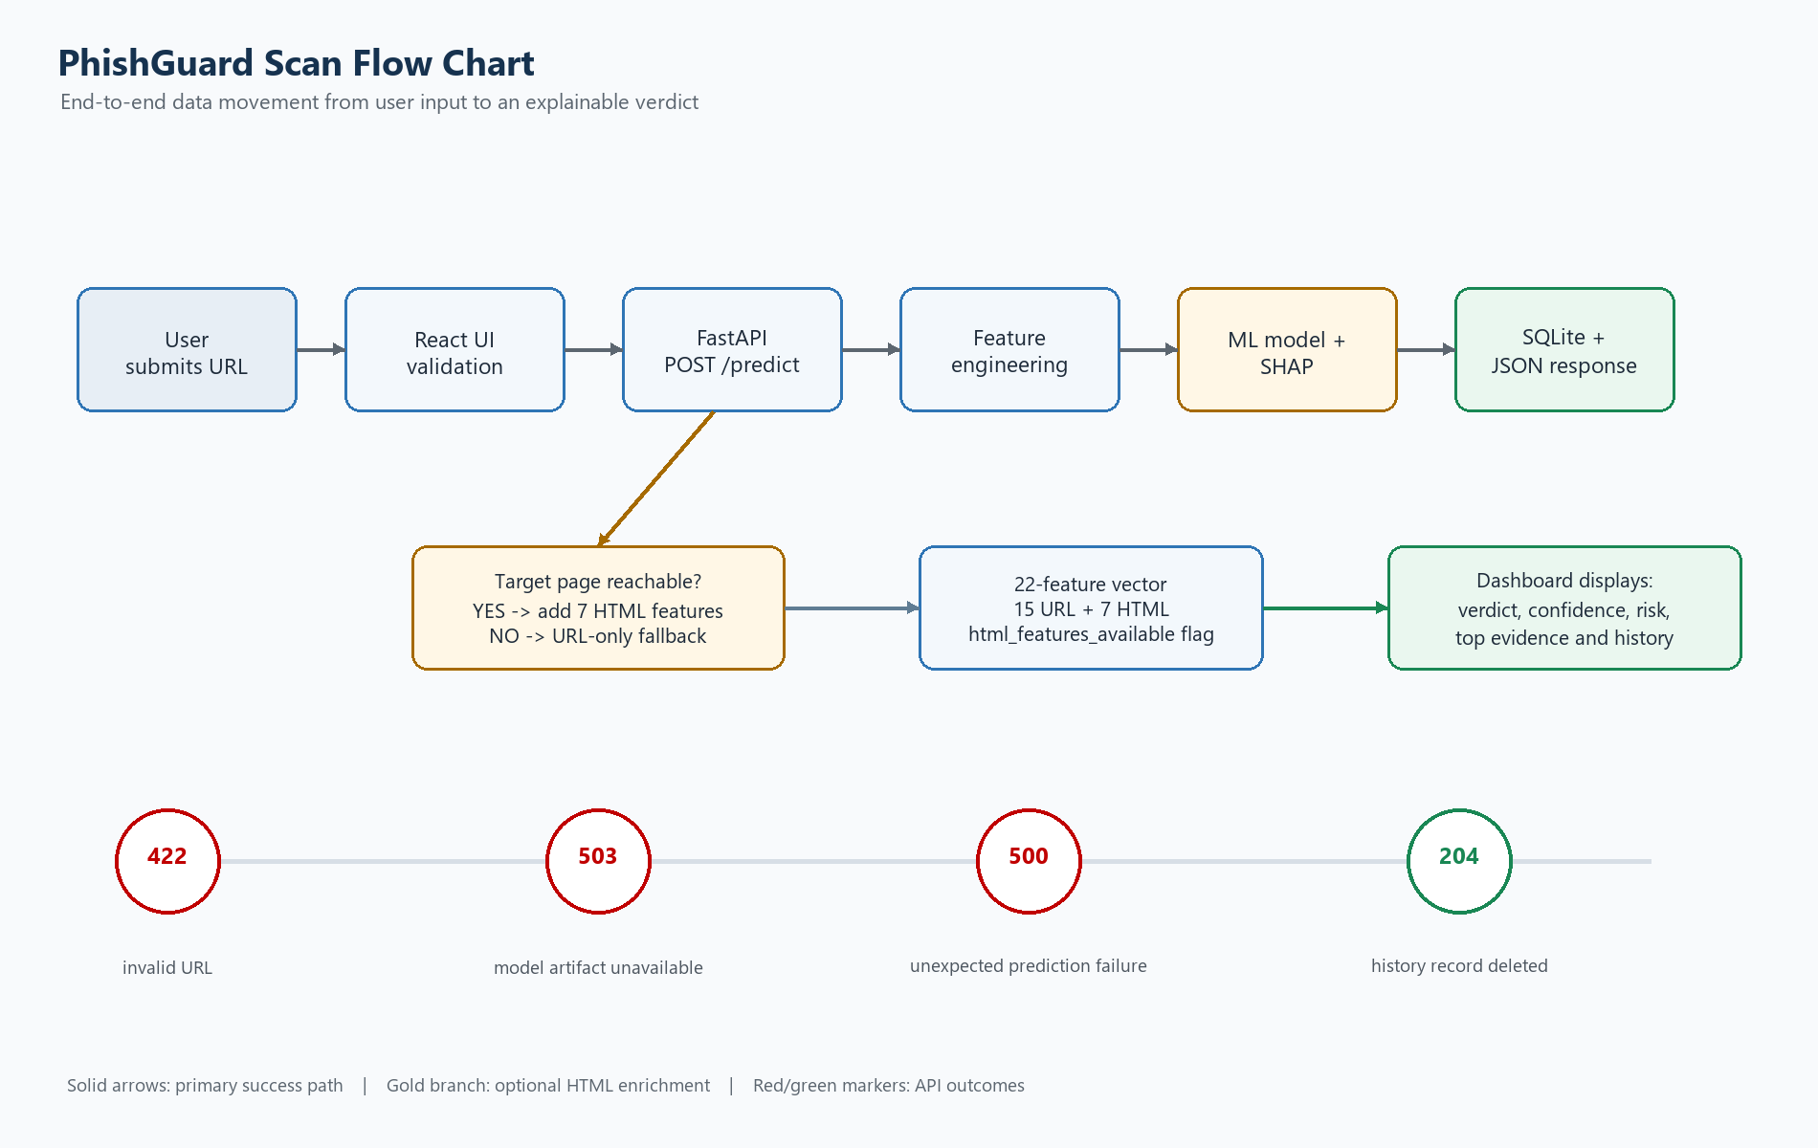
Figure 14-1. PhishGuard scan flow chart.

15. Acceptance Criteria
ID | Acceptance criterion | Evidence
AC-01 | A valid URL returns HTTP 200 with scan id, prediction, confidence, risk score, risk level, features, top features, model version, and timestamp. | API test response
AC-02 | The response contains exactly 22 feature values plus html_features_available. | Schema/unit test
AC-03 | An unreachable target still returns a URL-only prediction and clearly marks HTML enrichment unavailable. | Integration/failure test
AC-04 | An invalid URL returns HTTP 422 and creates no scan-history record. | Negative API test
AC-05 | A prediction is stored and can be retrieved from paginated history. | Database and API test
AC-06 | An existing record can be deleted and a missing record returns HTTP 404. | API test
AC-07 | The dashboard can present verdict, risk, confidence, evidence, and the full feature matrix. | UI demonstration
AC-08 | The SRS package contains the problem statement, scenario document, use case diagram, activity diagram, and flow chart aligned to implementation behavior. | Document review

16. Risks, Constraints, and Future Work
Risk / constraint | Consequence | Mitigation / future work
False positive or false negative | A legitimate site may be flagged or a phishing site may be missed. | Show confidence and evidence, keep the user in the review loop, retrain with representative data, and monitor metrics.
HTML fetch / SSRF exposure | Fetching arbitrary URLs can consume resources or reach unintended internal services. | Apply timeouts, response-size limits, URL/IP policy checks, egress restrictions, and production SSRF controls.
Feature drift | Attackers can change URL and page construction patterns. | Track history, review explanations, refresh datasets, and compare candidate models periodically.
SQLite concurrency limits | High concurrent writes can cause contention. | Retain SQLite for mini-project scale; migrate to a production database for larger deployments.
Fallback model overconfidence | Heuristic predictions may look authoritative without a trained artifact. | Identify fallback mode in model metadata and reports; never present fallback values as trained-model metrics.
No authentication in baseline | Anyone with network access can submit URLs and view/delete local history. | Add authentication, authorization, audit logging, and deployment isolation in a future release.

Appendix A - API Summary
Method / path | Purpose | Important response
GET /health | Liveness/readiness check. | status, model_loaded, database_connected
POST /predict | Validate, analyze, explain, persist, and return one URL scan. | scan_id, prediction, confidence, risk_score, risk_level, features, top_features, html_features_available
GET /history | Return paginated history with optional prediction filter. | items and pagination
DELETE /history/{id} | Delete one existing scan history record. | 204 on success; 404 if missing
GET /model-info | Return active model metadata and evaluation metrics. | model name/version, metrics, dataset size, trained_at
GET /docs | FastAPI-generated interactive OpenAPI/Swagger UI. | Interactive endpoint documentation

Appendix B - Feature Dictionary
# | Feature | Group | Definition
1 | url_length | URL | Length of submitted URL.
2 | domain_length | URL | Length of extracted registrable domain.
3 | num_dots | URL | Count of dots across the URL.
4 | num_hyphens | URL | Count of hyphens.
5 | num_digits | URL | Count of decimal digits.
6 | num_subdomains | URL | Number of subdomain labels.
7 | has_https | URL | Whether the scheme is HTTPS.
8 | has_ip_address | URL | Whether hostname is an IP literal.
9 | has_at_symbol | URL | Whether URL contains @ user-info syntax.
10 | has_double_slash_redirect | URL | Whether an extra // appears after the scheme.
11 | is_shortened_url | URL | Whether hostname matches a known shortener.
12 | num_suspicious_chars | URL | Count of @, %, _, =, and & obfuscation characters.
13 | url_entropy | URL | Shannon entropy of URL characters.
14 | has_suspicious_tld | URL | Whether suffix is in the configured abused-TLD set.
15 | path_length | URL | Length of parsed URL path.
16 | has_iframe | HTML | Whether HTML contains an iframe.
17 | redirect_count | HTML | Number of HTTP redirects followed.
18 | num_external_links | HTML | Count of anchor links to other hostnames.
19 | form_action_suspicious | HTML | Whether a form action is empty, external, or an IP literal.
20 | has_javascript_events | HTML | Whether inline event handlers are present.
21 | has_popup_window | HTML | Whether JavaScript calls window.open().
22 | has_hidden_elements | HTML | Whether inline styles hide elements.
- | html_features_available | Metadata | Whether the seven HTML features were computed from fetched page content.

Model baseline: The repository comparison report records RandomForest as the selected model because it has the highest F1 and ROC-AUC in the current benchmark: accuracy 0.9195, precision 0.8992, recall 0.8873, F1 0.8932, ROC-AUC 0.9693, dataset size 1,225,480. These are benchmark values, not a guarantee for every future dataset or URL population.

